CHECKING THE STATUS

Status of a files in the folder can be checked by using command ‘git status’
Prepare your Folder
Create a folder (for example - ‘Git test’) on your local computer.
Add a file in the folder
Checking git status using – Git Bash
Right click the folder and select ‘Open Git Bash here’ (under ‘show more options’), following window appears
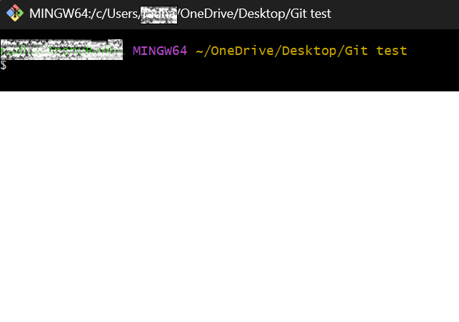
If the folder is not initialised using command ‘git init’ the following window appears with a message – “not a git repository”
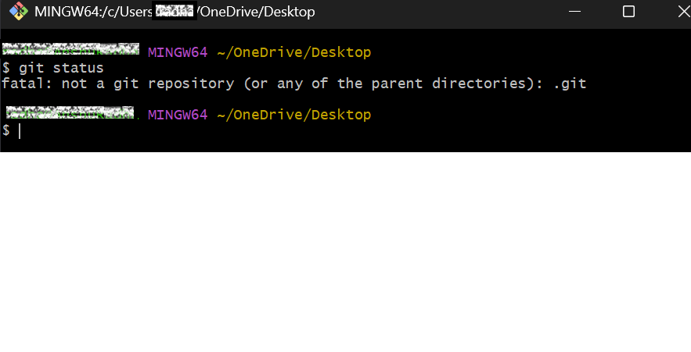
Once the folder is initialised, Type ‘git status’ as shown in image below to check the status of files in the folder
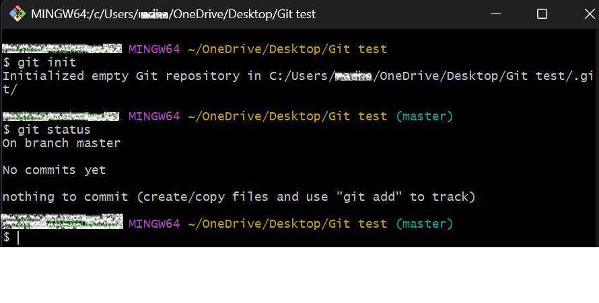

Checking git status using - Terminal
Right click the folder and select ‘Open in Terminal’ and type ‘git status’. If the folder is not initialised, Terminal will show the message – ‘not a git repository’
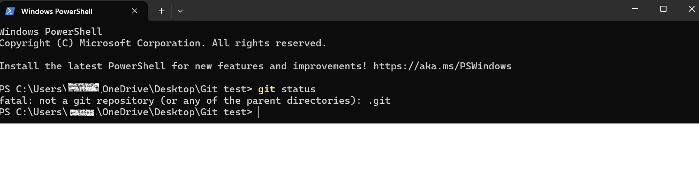
Once the folder initialised using the command ‘git init’, Type ‘git status’ as shown in image below to check the status of files in the folder
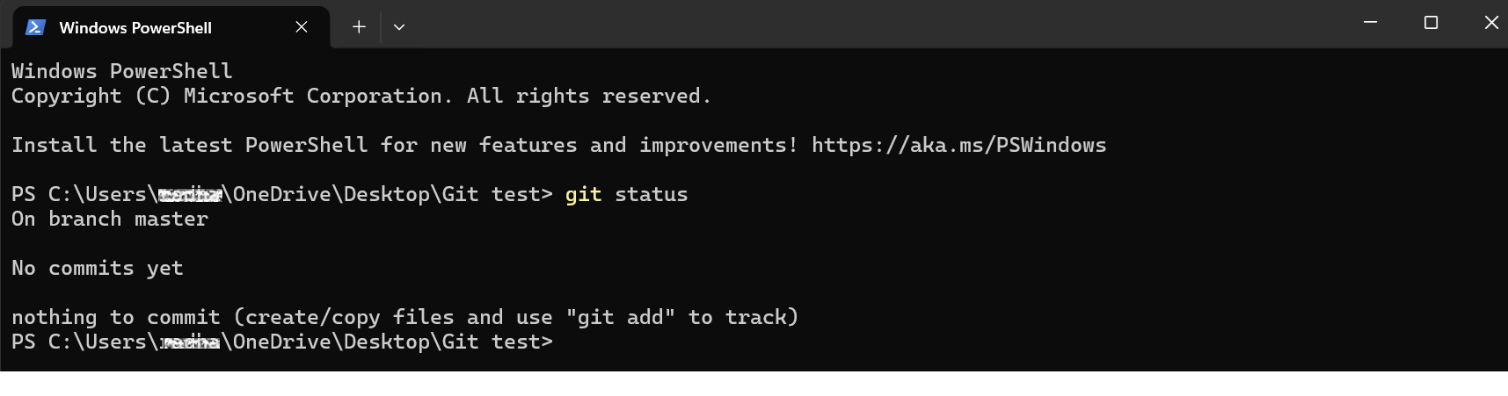

Checking git status using – VS code
Right click the folder and select ‘Open with code’
In VS Code, click the 3 dots (…) menu and select Terminal – ‘New terminal’ as shown below
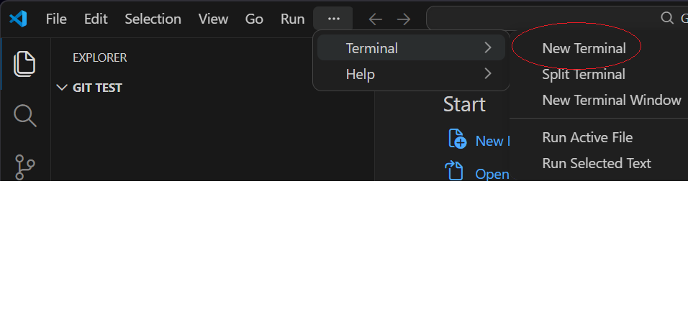

Click on ‘v’ icon next to the + on the top right-hand side of the Terminal and select ‘Git Bash’ as shown below
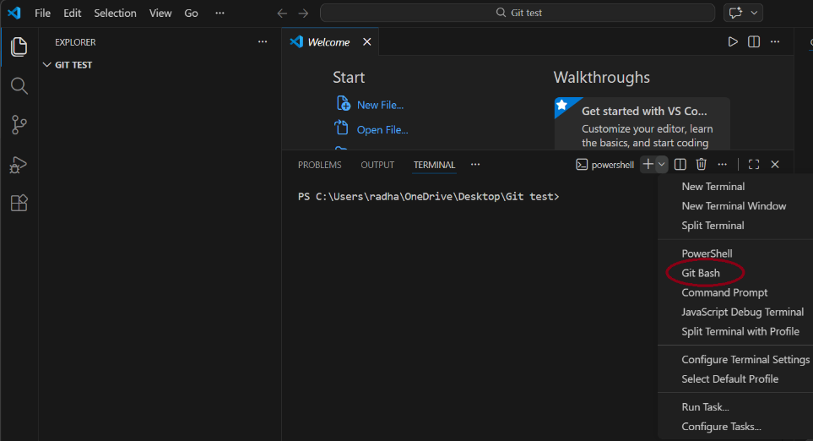
Type ‘git status’, following window appears with a message – ‘not a git repository’, If the folder is not initialised,
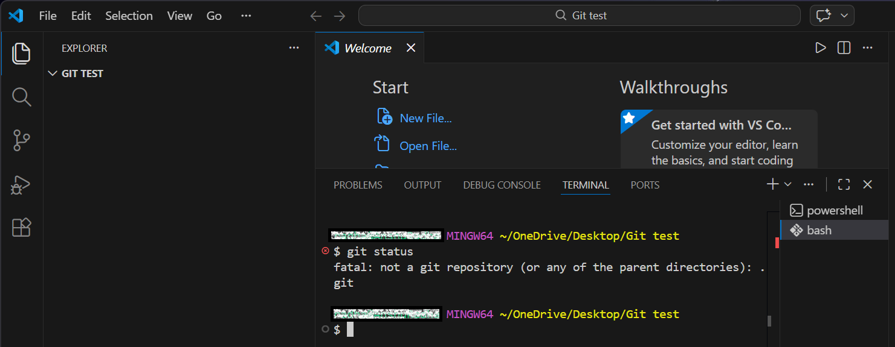

Once the folder initialised using the command ‘git init’, Type ‘git status’ as shown in image below to check the status of files in the folder
